Customer / -no.:
ZIP code, location:
Contact person:
Business:
Project declaration:
Sales responsible/date:

☐ end customer with single need for_______ pcs.

☐ end customer with recurrent need for ______ pcs./year

☐ OEM with need for different applications for _____ pcs./year

☐ OEM with need for same applications for _____ pcs./year

☐ System integrator _____ pcs./year

Customer requirements
feasibility: until CW…………
implementation: until CW…………

Budget: | €
Annual budget for vision-systems:
Competitor:
Probability of realization: | %

Parts to be inspected:

Parts (sketch):: |  | 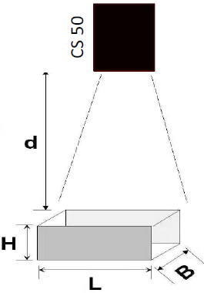
Length/width/height: | mm³
Working distance [d]: | mm
Description and condition of parts / variants:
Method of inspection: | ☐ detection of position  ☐ presence/absence/completeness  ☐ shape ☐ count  ☐ others_______________________
Inspection characteristic /
errors:
(Borderline parts)
Feature(s) to be inspected:
(passed/non-passed)

accuracy /
tolerance

description of task:
(What does the customer expect? Process details)

feeding:

☐ Zuführband / Linearförderer ☐ Manual workstation
☐ ball feeder ☐ rotary indexing table
☐ Workpiece carrier system ☐ _____________________

conveyor speed:
vibrations:
(strength)
Cycle times /
parts /min:
Others:

Guidance / Positioning:

Way of guiding:
(how is it guided?)

Accuracy (in mm):
(can the product turn, rotate…?)

Shaded areas:
(Can the product be shaded somehow by something?)

vision sensor:

☐ CS50 ☐ CS60

Relative orientation of sensor to the product. (side, perpendicular, …?)
Environmental conditions:
(dirt, heat, oil, ESD etc.)
light effects:
(Daylight, neon/LED lamps, etc.)
Can the area be sheltered from the sun?
(Blackbox)
Others:

Communication required:

☐ Digitale I/O´s ☐ ProfiNet
☐ Ethernet/IP (Only CS50) ☐ TCP/IP

Trigger Signal:

How is triggered? | ☐ machine control ☐ sensor  ☐ Output of machine / robot  ☐ Continuous

Lighting:

☐ Internal vision sensor illumination sufficient / preferred?
recommendation:
☐ Built-in advanced lighting (red/white) until 200mm
☐ Built-in advanced lighting (blue) until 150mm
☐ Built-in advanced lighting (IR) until 100mm

☐ External lighting necessary / required (e.g. BEK-R33…)?
(CS-50: for distances > 200mm, CS-60 for distances > 500mm is an ext. Lighting recommended)

External Lighting/type:
Working distance:
Relative position to the product:
other
installation instructions:

Equipment:

connection cable: length of RJ45 2/5/10m
(5m is also angled available) lenght of powercable 2/5/10/20m

Sample parts:

☐ Samples will be sent to…
(sufficient number and types of product parts)

☐ No samples available (Application Specialist required at the customer)

☐ Demo-case needed (max. 14 days) from CW …………..

